Assignment Cover Sheet

|  |  |
| --- | --- |
| **Student Names &**  **Student Numbers** | 17979610 - Jonathan Clarke  17715469 - Jordan Houang  18381779 - Sado Shanaa  17818155 - Omar Al-Jumaily |
| **Unit Name and Number** | 300579 Professional Experience |
| **Title of Submission** | Project Plan |
| **Due Date** | 8/06/2018 |
| **Date Submitted** | 3/06/2018 |

**DECLARATION**

***I hold a copy of this assignment that I can produce if the original is lost or damaged.***

***I hereby certify that no part of this assignment/product has been copied from any other student’s work or from any other source except where due acknowledgement is made in the assignment. No part of this assignment/product has been written/produced for me by another person except where such collaboration has been authorized by the subject lecturer/tutor concerned.***

***I hereby certify that I have read and understand what the School of Computing and Mathematics defines as minor and substantial breaches of misconduct as outlined in the learning guide for this unit.***

***Signature: ……Sado Shanaa………………………………………………………….***

Handover & Completion Report

ANSTO System Upgrade

Prepared By: Group CA1802

Prepared For: Australian Nuclear Science & Technology Organization (ANSTO)

Team

Jonathan Clarke

Jordan Houang

Sado Shanaa

Omar Al-Jumaily

3/06/2018

# Table of Contents

Table of Contents 3

Implemented Database Schema 4

Task Results 5

# 

# Implemented Database Schema

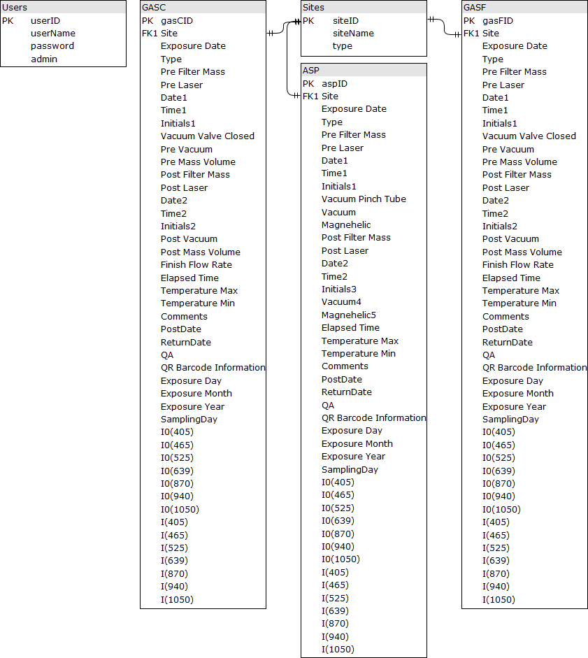

# Task Results

|  |  |  |  |
| --- | --- | --- | --- |
| **Use Case/Feature** | | User Login – Validation Testing | |
| **Interface Ref:** | |  | |
| **Test Purpose** | | To ensure only existing users can access the system using their login credentials. | |
| **Expected Results** | | See Individual Test Data Sets | |
| **Success/Failure** | | Success | |
| **Test Results** | | | |
| **Column Name** | **Set 1** | **Set 2** | **Set 3** |
| Username (Mandatory) |  |  |  |
| Password (Mandatory) |  |  |  |
| Expected Results | Pass | Pass | Fail |
| Result | Pass | Pass | Fail |
| Date Tested | X/06/2018 | X/06/2018 | X/06/2018 |
| Actions to be taken | No action. | No Action. | No Action. |

|  |  |  |  |
| --- | --- | --- | --- |
| **Use Case/Feature** | | Add Site – Validation Testing | |
| **Interface Ref:** | |  | |
| **Test Purpose** | | To ensure all mandatory fields are entered with acceptable input and a site is added to the database after validation. | |
| **Expected Results** | | See Individual Test Data Sets | |
| **Success/Failure** | | Success | |
| **Test Results** | | | |
| **Column Name** | **Set 1** | **Set 2** | **Set 3** |
| ID (Mandatory) | 99 | 1 |  |
| Site Name (Mandatory) | China Town | China Town |  |
| Type (Mandatory) | GAS | ASP | ASP |
| Expected Results | Pass | Fail | Fail |
| Result | Pass | Fail | Fail |
| Date Tested | 2/06/2018 | 2/06/2018 | 2/06/2018 |
| Actions to be taken | No action | No Action. Since the ID ‘1’ already existed in the database, the set was not passed. | No Action. The validation check made sure this did not pass since mandatory fields were left blank. |

|  |  |  |  |
| --- | --- | --- | --- |
| **Use Case/Feature** | | Generate Logsheet | |
| **Interface Ref:** | |  | |
| **Test Purpose** | | To ensure this feature works correctly; A logsheet must only be generated if there are enough new filters available for allocation in the database.  This test is setup so there are 4 new ASP, 2 new GAS-C and 2 new GAS-F filters available for allocation in the | |
| **Expected Results** | | See Individual Test Data Sets | |
| **Success/Failure** | | Success | |
| **Test Results** | | | |
| **Column Name** | **Set 1** | **Set 2** | **Set 3** |
| Sites (Mandatory) | ASP01  ASP10  ASP23 | ASP01  ASP10 | GAS35 |
| Day-Pair (Mandatory) | Wednesday 11/07/2018 & Sunday 15/07/2018 | Wednesday 11/07/2018 & Sunday 15/07/2018 | Wednesday 08/08/2018  & Sunday  12/08/2018 |
| Expected Results | Fail | Pass | Pass |
| Result | Fail | Pass | Pass |
| Date Tested | 2/06/2018 | 2/06/2018 | 2/06/2018 |
| Actions to be taken | No action. 6 New ASP filters were required for this to pass. | No Action. | No Action. |

|  |  |  |  |
| --- | --- | --- | --- |
| **Use Case/Feature** | | Mark Filters as Sent | |
| **Interface Ref:** | |  | |
| **Test Purpose** | | To ensure this feature works correctly; The system must find and display filters that have not been sent which correspond to the user’s selected site & day-pair and mark them as sent using the current date.  The filters allocated in the ‘Generate Logsheet’ test will be used for testing here. | |
| **Expected Results** | | See Individual Test Data Sets | |
| **Success/Failure** | | Success | |
| **Test Results** | | | |
| **Column Name** | **Set 1** | **Set 2** | **Set 3** |
| Sites (Mandatory) | ASP01  ASP10 | GAS35 | GAS33 |
| Day-Pair (Mandatory) | Wednesday 11/07/2018 & Sunday 15/07/2018 | Wednesday 08/08/2018  & Sunday  12/08/2018 | Wednesday 08/08/2018  & Sunday  12/08/2018 |
| Expected Results | Pass | Pass | Fail |
| Result | Pass | Pass | Fail |
| Date Tested | 2/06/2018 | 2/06/2018 | 2/06/2018 |
| Actions to be taken | No action. | No Action. | No Action. There are no allocated filters in the database associated with the selected site and day-pair. |

# Variations Report

|  |  |  |  |
| --- | --- | --- | --- |
| **Type** | **Variation** | **Initiated By** | **Implemented or Not** |
| **Functional** | Add a new use case – Mark Filters as Sent | Client | This was not initially identified by the client, but has been implemented |
| Add a new use case – Set Default Sites | Client | To be included as further development. This was mentioned in week 12 by the client. |
| **Data** | Added new fields: Date1, Time1, Initials1, Date2, Time2 and Initials2 | Client | Implemented |
| Split `Exposure Code` into: Site, Exposure Date & Type | Team | Implemented |
| Split `Exposure Date` into: Exposure Day, Exposure Month, Exposure Year | Client | Implemented |
| **Screen** | Display text ‘Filter By Options’ instead of carrot (arrow) on the filter button. | Client | Implemented |

# Outstanding Issues

Known Bugs

There are no known bugs.

Further Improvements

|  |  |  |
| --- | --- | --- |
| **Improvement Title** | **Type** | **Description** |
| Set Default Sites | Functional | The client wants to be able to select which sites are checked by default when accessing the generate logsheets page. |
| Upload Data | Functional | The client wants the ability to upload a CSV file filled with data and import this new data into the database. |
| Improved code | Back-End | The HTML and CSS can be improved. |
| Log changes | Functional | The client wants an admin-only function that allows the admin to view all changes made by any other account. This includes having to record every action a user performs. |